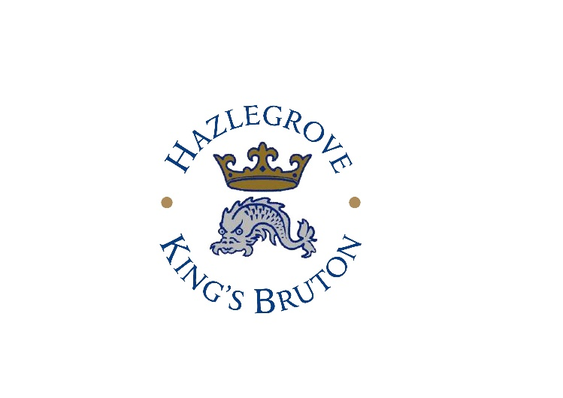

SCHOOL BUS ROUTES: September 2026-2027

Route 1 -Hazlegrove Pupils Only | Shepton Mallet – East Pennard – Ditcheat – Bruton – Castle Cary – Hazlegrove | Morning | Evening
Shepton Mallet | Dobbies | 7.20am | 7.10pm
East Pennard |  | 7.35am | 6.55pm
Ditcheat |  | 7.45am | 6.45pm
Bruton | King’s Bruton Lay-by | 7.50am | 6.30pm
Castle Cary |  | 8.05am | 6.15pm
Hazlegrove | Hazlegrove | 8.20am | 6.00pm

Route 2 – Hazlegrove Pupils Only | Yeovil – Milbourne Port – West Mudford - Hazlegrove | Morning | Does not run
Milbourne Port | Village Hall | 7.00am
Dorchester Road Yeovil |  | 7.25am
West Mudford |  | 7.55am
Hazlegrove |  | 8.20am

Route 3 – Hazlegrove and King’s Pupils | Warminster – Zeals - Bourton – Wincanton - Hazlegrove | Morning | Evening
Warminster | Crockerton Trading Estate Gray’s Carpets | 7.10am | 6.55pm
Willoughby Hedge | Lay-by A350 | 7.25am | 6.40pm
Zeals |  | 7.40am | 6.30pm
Bourton |  | 7.45am | 6.25pm
Wincanton | Hunter’s Lodge | 7.50am | 6.20pm
Wincanton | Lidl Car Park  King’s pupils change here Bus Route 6 (AM) | 8.00am | 6.15pm
Hazlegrove | Hazlegrove | 8.20am | 6.00pm

Route 4 – Hazlegrove and King’s Pupils | Ilminster – Cartgate -Hazlegrove | Morning | Evening
Ilminster | Eagle Tavern Pub Car Park | 6.50am | 7.05pm
Ilminster | Garage – Southfields Roundabout | 7.10am | 6.45pm
Cartgate | Roundabout Service Area  King’s pupils change here Bus Route 7 (AM) | 7.35am | 6.25pm
Hazlegrove | Hazlegrove | 8.05am | 6.00pm

Route 5 – King’s Pupils Only | Tisbury - Shaftesbury – Gillingham - Bruton | Morning | Evening
Tisbury | The Boot Inn | 7.10am | 7.00pm
Shaftesbury | Ivy Cross | 7.35am | 6.35pm
Port Regis | Lay-by by Port Regis Dining Room | 7.40am | 6.30pm
Gillingham | Waitrose Car Park | 7.50am | 6.20pm
Hunters Lodge | Hunters Lodge | 8.05am | 6.05pm
Bruton | King's Bruton | 8.20am | 5.50pm

Route 6 - Hazlegrove and King’s Pupils | Sherborne - Hazlegrove – Wincanton - Bruton | Morning | Evening
Sherborne | Greenhills Shelter | 7.20am | 6.50pm
Marston Magna | Village Hall | 7.35am | 6.40pm
Hazlegrove | Hazlegrove | 7.45am | 6.30pm
Wincanton | Lidl Car Park  King’s pupils change here Bus Route 3 (PM) | 8.00am | 6.15pm
Bruton | King's Bruton | 8.15am | 5.50pm

Route 7 - King’s Pupils Only | Cartgate – Podimore - Lydford - Bruton | Morning | Evening
Cartgate Roundabout | Service Area  King’s pupils change here Bus Route 4 (PM) | 7.35am | 6.25pm
Podimore Roundabout | Service Area | 7.40am | 6.15pm
Lydford Crossroads | Cross Keys Inn | 7.50am | 6.05pm
Bruton | King's Bruton | 8.20am | 5.50pm

Route 8 – King’s Pupils Only | Frome – Nunney – Wanstrow - Bruton | Morning | Evening
Frome | Greggs Car Park (opposite The Range) | 7.50am | 6.20pm
Nunney Catch | Nunney Catch Lorry Stop | 7.55am | 6.10pm
Wanstrow | Wanstrow Community Centre | 8.00am | 6.05pm
Bruton | King's Bruton | 8.15am | 5.50pm

Route 9 – King’s Pupils Only | Wells – Shepton Mallet – East Pennard – Ditcheat – Batcombe - Bruton | Morning | Evening
Wells | Morrisons Car Park | 7.20am | 6.50pm
Shepton Mallet | BP Cannards Grave | 7.35am | 6.35pm
East Pennard | Church Grass Triangle | 7.45am | 6.25pm
Ditcheat | The Manor House Inn | 7.55am | 6.15pm
Batcombe | Outside Church | 8.10am | 6.00pm
Bruton | King's Bruton | 8.20am | 5.50pm

MORNINGS
- All routes available Monday to Saturday in the mornings. Except Route 2, 4 and 8 available Monday – Friday morning but do not run on a Saturday morning.

EVENINGS
- All Routes available Monday – Friday in the evening. Except Route 2 does not run in the evenings and Route 8 available Monday – Thursday in the evening but does not run on a Friday evening.

- You will be notified of any other changes.
- All costs are charged per single journey and will be put on the end of term fees invoice. Transport Costs (Academic Year 2026–27). Per term: £540.00. AM / PM only : £270. Individual journey: £5 / journey.
- The School reserves the right to alter bus routes depending on demand.

Exeat and Half Term: Hazlegrove run a return journey for Exeat at 4.00pm and Half Term at 12.45pm (Autumn and Spring) and 4.00pm (Summer). King’s will run return journey at the earlier time of 1.30pm. Route 8 does not run a return journey on exeat and half term if it falls on a Friday.
End of Term : Hazlegrove NO return buses. King’s NO return buses if it is a Saturday. Routes 5,6,7 and 9 run return buses on all other days. Route 8 no return journey at end of term.

For more information please contact HAZLEGROVE Office (office@hazlegrove.co.uk) and KING’s BRUTON Penny Bird (travel@kingsbruton.com)

