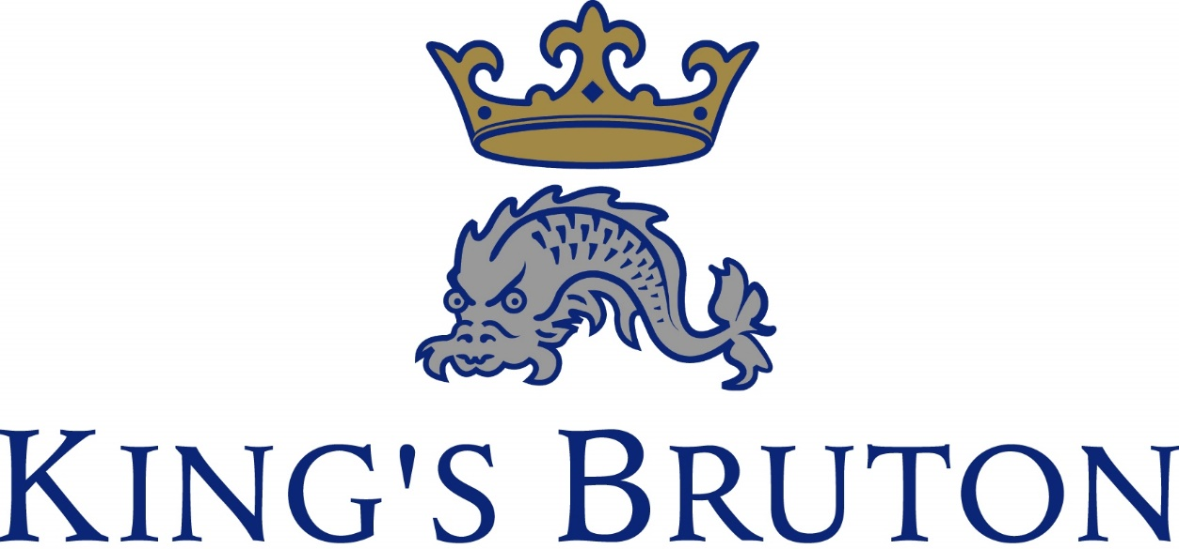

HMC co-educational boarding school
situated in the small Somerset town of Bruton

Appointment of

FOUNDATION DESIGNATED SAFEGUARDING LEAD

For September 2026

King’s Bruton

King’s School, Bruton is a co-educational boarding and day school for pupils aged 13 to 18 years. It is situated in the historic town of Bruton about an hour from Bath, Bristol, Salisbury and Taunton. There is a train service from Bruton and Castle Cary (First Great Western) and Gillingham, (South West Trains).

The School was founded in 1519 and re-founded, after the dissolution of the monasteries, in 1550. Girls were admitted for the first time in 1969, initially in the 6th Form, but throughout the School from 1997. There are currently 330 pupils of which 140 are in the 6th Form.

Pupils come from a wide geographical area in the South-West of England, and across the social spectrum. Over 50% of pupils board with 12% of the intake coming from abroad. Day pupils are fully integrated into 6 boarding houses. Our main feeder school is Hazlegrove Preparatory School, but pupils also come from a number of other preparatory schools as well as a small proportion from the state system.

In 2023 the school passed its ISI Compliance inspection and in 2018 the school was rated as ‘Good’ and ‘Excellent’ in its ISI Quality Inspection.

Hazlegrove is a thriving South West Co-Educational Prep School for children aged 2-13. Pupil roll is around 380 with 80 full boarders. Based around an 18th century house and set in 200 acres of parkland, the school enjoys outstanding facilities.

We are delighted to report that, in our June 2023 ISI inspection, inspectors considered the quality of pupils’ academic and other achievements as ‘Excellent’. They also deemed the quality of the pupils’ personal development as ‘Excellent’.

King’s Bruton and Hazlegrove offer concessions on fees for the children of teaching and support staff of both schools.

King’s Foundation is totally committed to safeguarding and promoting the welfare of children. The school has a range of policies and procedures for child protection and security. All staff at Hazlegrove are expected to understand and follow all of these policies and procedures as part of their professional responsibilities.

Further details of the School can be found by visiting our website: www.kingsbruton.com.

FOUNDATION DESIGNATED SAFEGUARDING LEAD
King’s Bruton & Hazlegrove Preparatory School
Part-time | From September 2026
An outstanding opportunity has arisen for an experienced, confident and compassionate Foundation Designated Safeguarding Lead (FDSL) to work across King’s School Bruton and Hazlegrove Preparatory School, together forming a vibrant Foundation of approximately 720 pupils aged 2–18.
This is a pivotal role with strategic and operational responsibility for all safeguarding and child protection matters across both schools. Working closely with the Headmasters, senior leadership teams, governors and external agencies, the FDSL will lead safeguarding practice, manage referrals, oversee policies and procedures, and support and coordinate Deputy DSLs at each school.
The successful candidate will be a visible and trusted presence, providing expert advice and guidance to staff, delivering training, and helping to embed a strong safeguarding culture throughout the Foundation. The role also encompasses oversight of wellbeing and mental health, online safety and Prevent duty responsibilities.
We are seeking a highly organised professional with substantial safeguarding experience, sound judgement and excellent communication skills. You will bring warmth, resilience and authority to the role, with a clear commitment to promoting the welfare and wellbeing of children and young people.
Set in the heart of Somerset, King’s Bruton and Hazlegrove are known for their strong pastoral care, inclusive values and genuine sense of community. This role offers the opportunity to make a meaningful and lasting contribution to two schools where safeguarding is central to everything they do.
Whilst this is anticipated to be a part-time position, the Foundation recognises the importance of attracting the right individual and is therefore open to considering different working arrangements, subject to discussion and the operational needs of the schools.

Safeguarding and the Welfare of Children

King’s Foundation, is totally committed to safeguarding and promoting the welfare of children. The school has a range of policies and procedures for child protection and security. All staff at King’s are expected to understand and follow all of these policies and procedures as part of their professional responsibilities.

During the interview process, candidates should expect to be questioned about issues that are relevant to safeguarding children. Candidates should also be aware that referees will be asked to comment on a candidate’s disciplinary record and whether or not the candidate has been the subject of any child protection concerns.

The successful candidate will be subject to an enhanced DBS (Disclosure and Barring Service) disclosure and other vetting checks suitable to the post.

Applications

Further details may be obtained from King’s website: https://www.kingsbruton.com/about-us/vacancies Letters of application, completed application forms with curriculum vitae, should be sent to recruitment@kingsbruton.com
Closing date: 12 noon on Friday 20 February 2026
Interviews will be held at the start of the week beginning 2nd March 2026

